Upcoming Presentation at the Freight Shed in Bath:

Growing Vegetables in Maine
by Linton Studdiford
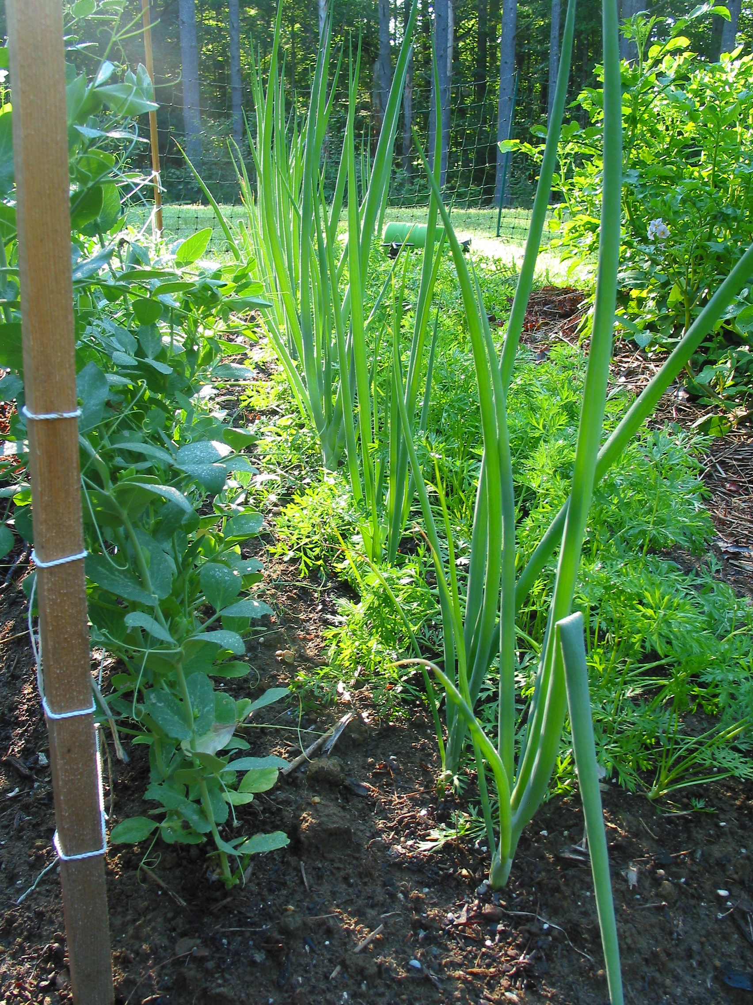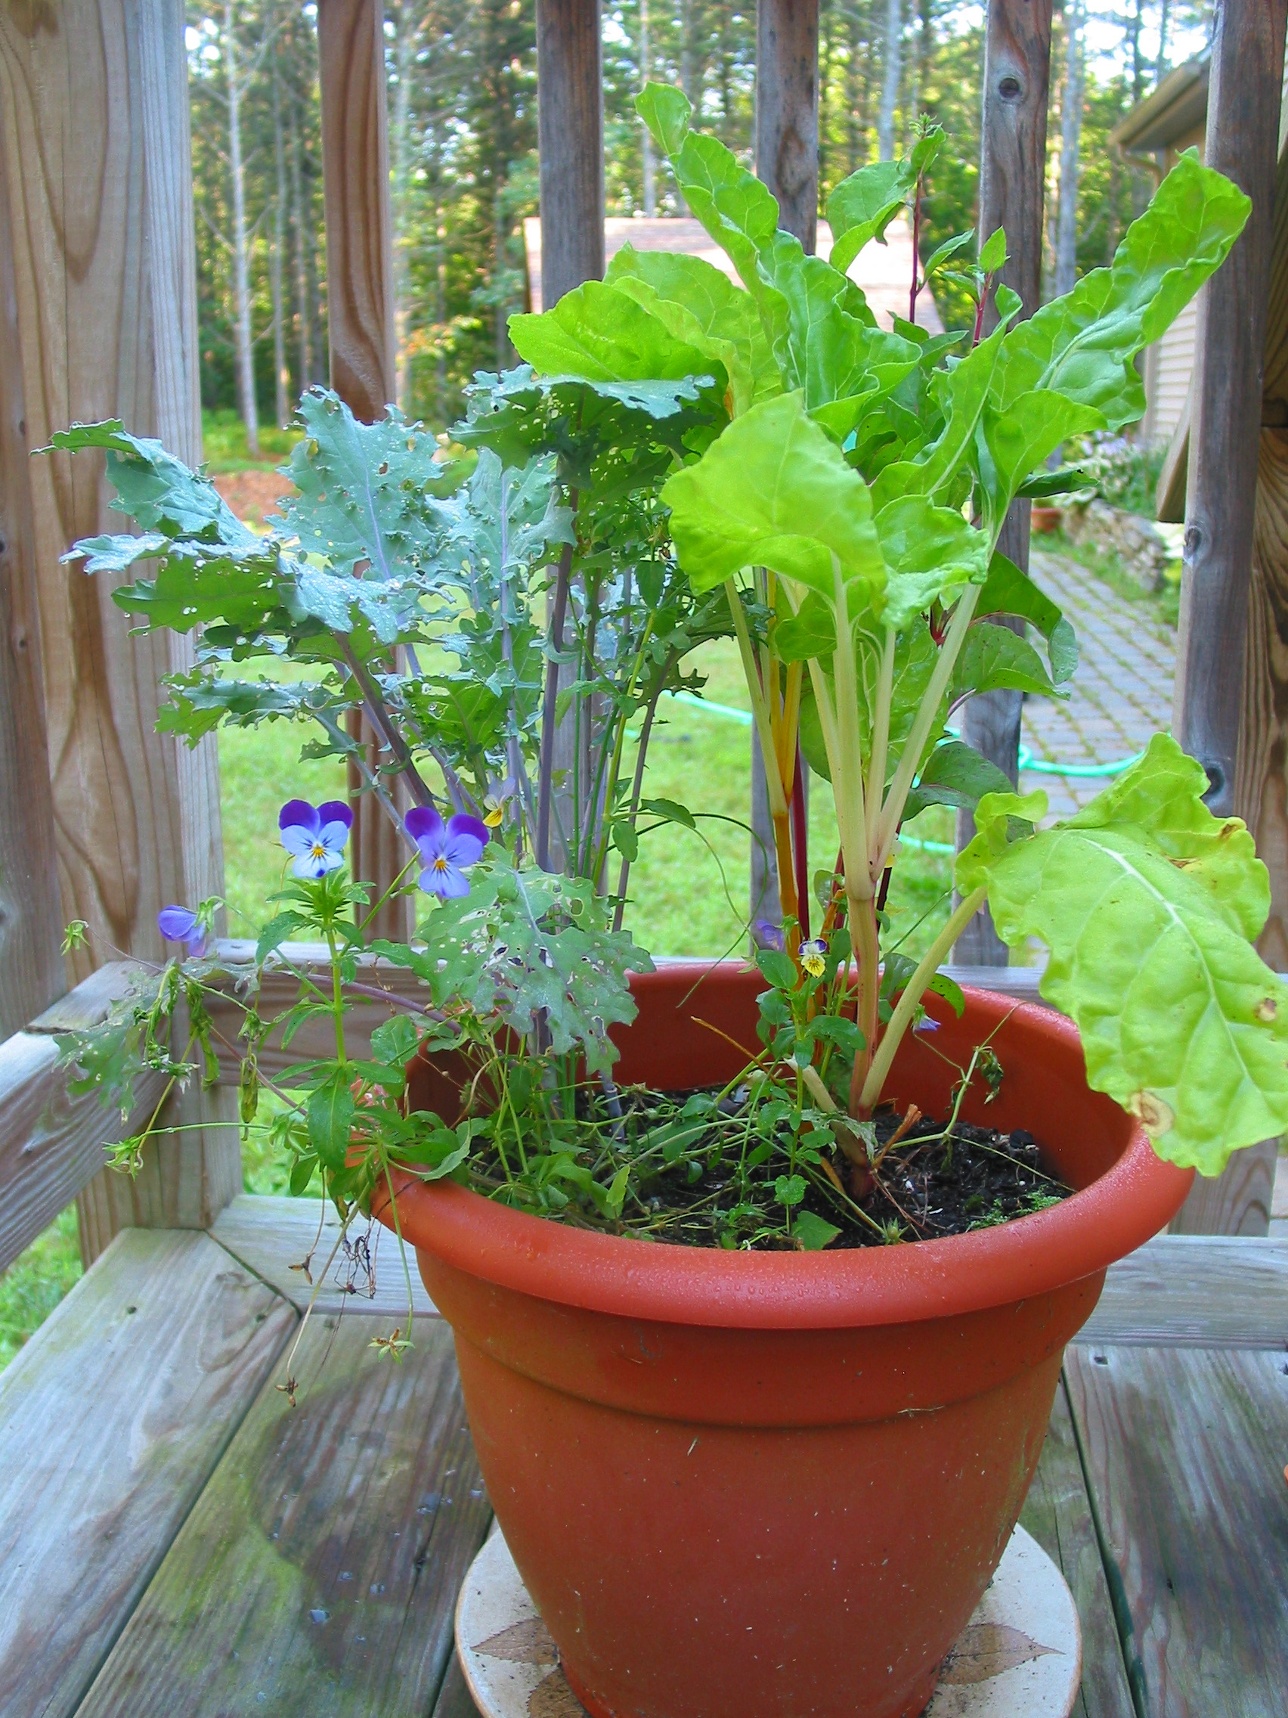

Linton Studdiford, who is a local master gardener, will show a slide show and answer questions about vegetable growing in the Mid-Coast area: best varieties, when to plant, seed sources, winter growing inside, and more.

Saturday, February 27, 2-3:30 p.m.
Bath Freight Shed, Commercial St., Bath, Maine

This free event is sponsored by:
Sagadahoc Chapter of Maine Organic Farmers and Gardeners Association

For details call 207-350-6062. Seating is limited so plan to arrive early.

